Copyright for test papers and marking guides remains with *West Australian Test Papers.*

Test papers may only be reproduced within the purchasing school according to the advertised Conditions of Sale.

Test papers should be withdrawn after use and stored securely in the school until Friday 30th November 2018.



**SEMESTER TWO**

**MATHEMATICS**

**SPECIALIST**

**UNITS 1 & 2**

**2018**

**SOLUTIONS**

***Calculator−free Solutions***

1. (a) (i) or ✓

(ii) ✓✓

(b) (i) ✓

(ii) ‘9’ from first set only: ✓

‘9’ from second set only: ✓

no ‘9’ chosen: ✓

total ✓ [8]

2. (a) (i) ✓

(ii) ✓✓

(b) ✓✓

(c)

✓✓ [7]

3. (a) ✓

(b) ✓✓

(c) ✓✓ [5]

4. (a) (i) ✓✓

A and B are inverses of each other. ✓

(ii) ✓

✓✓

4. (b) (i) T1 performs a rotation of 180°

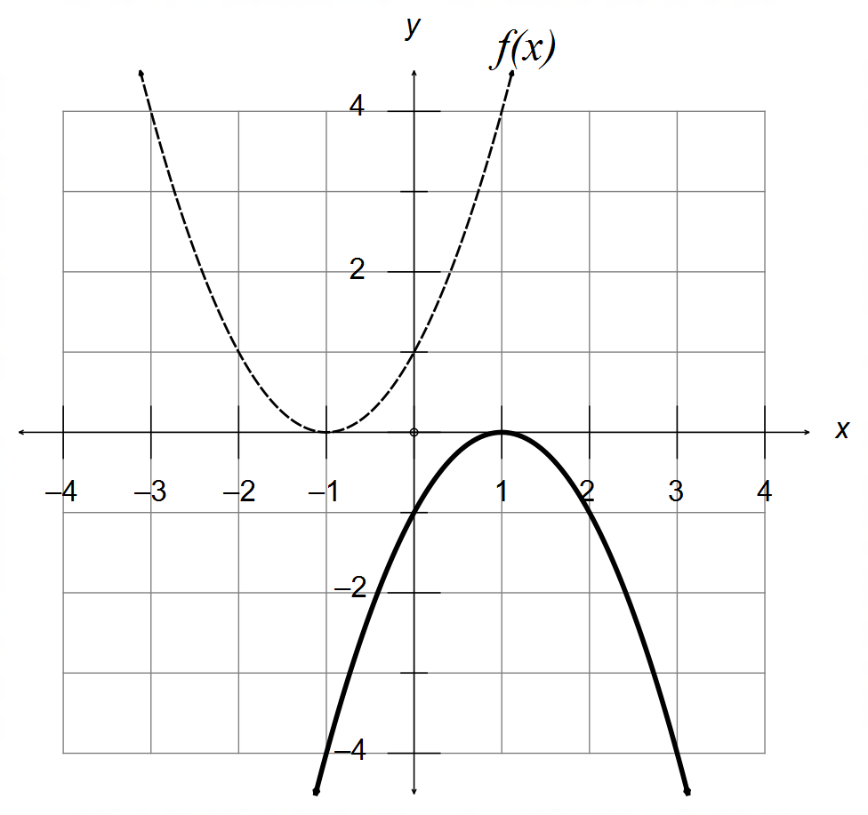

✓✓

(ii) Reflection of the line ✓

T2 ✓

(iii) New Area ✓✓ [12]

5. (a) (i)

✓✓✓

(ii) ✓✓

(b)

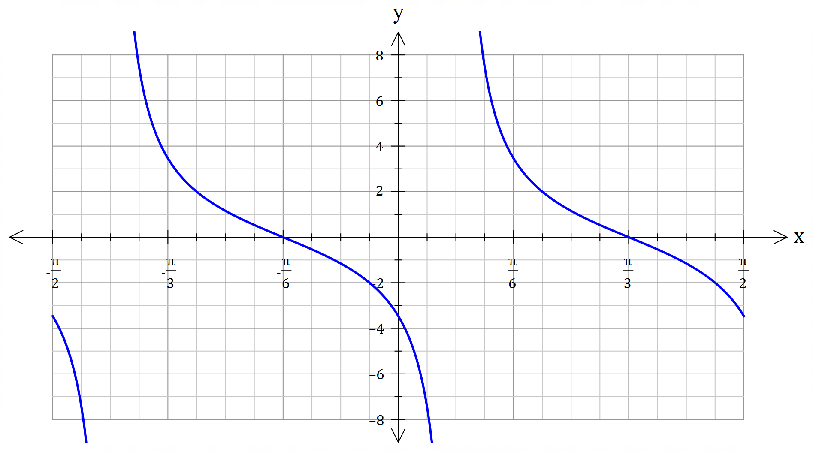

✓ Scale factor

( $y=2$ at )

✓ Period of

✓ Vertical Asymptote

at

[8]

6. (a) (i) ✓

(ii) “If $ab$ is irrational, then both $a$ and $b$ must be irrational” ✓

(b) A ⇒ B: If the triangle has two equal sides, then it is isosceles,

and therefore it has two congruent sides.

$∴$ A ⇒ B is valid and True. ✓

B ⇒ A: If the triangle has two congruent sides, then it is isosceles,

and therefore it has two equal sides.

$∴$ B ⇒ A is valid and True. ✓

A ⇔ B

(c) ✓✓ [6]

7. Assume $n$ is even and that $n^{3}$ is odd. ✓

Let $m∈N:n=2m$ is even. ✓

✓

Since $n^{3}$ cannot be both even and odd simultaneously, then this

is a contradiction. And therefore $n$ must be odd. ✓ [4]

***Calculator−assumed Solutions***

8. (a) ✓

✓

(b) Since then is also a solution ✓

✓

✓ [5]

9. LHS ✓

✓

✓

✓

✓

✓

✓

RHS ✓ [8]

10. (a) (i) ✓✓

(ii) ✓✓

(b) ✓

✓

✓

✓ [8]

11. (a) ✓

✓

(b) ✓

✓

(c) ✓

(d) For $n=2$: $S_{2}=\frac{1}{2}$ and $\frac{2!-1}{2!}=\frac{1}{2} ∴$ True for ✓

Assume true for :

✓

For :

✓

✓

✓

as required

Therefore, True for *n* = *k* + 1, and since true for *n* =2,

by induction the conjecture is true for all whole numbers. [10]

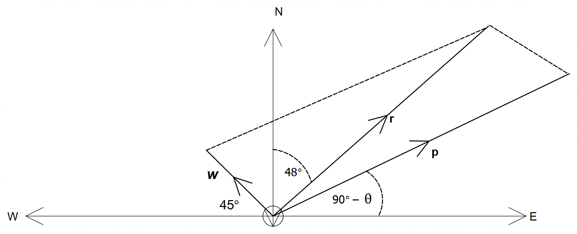12. (a)

✓ resultant

✓ wind

✓ plane

(b) ✓

✓

✓

(c)

✓

CAS: kmh-1 ✓

✓

(d) ✓✓ [11]

13. (a)

✓

✓

✓

(b)

✓

✓

✓ [6]

14. (a)

✓

✓

✓

✓

(b)

✓

✓ [6]

15. (a) (i) ✓

✓

(ii) ✓

✓

(b) (i) ✓

(ii) ✓

(c) ✓✓ [8]

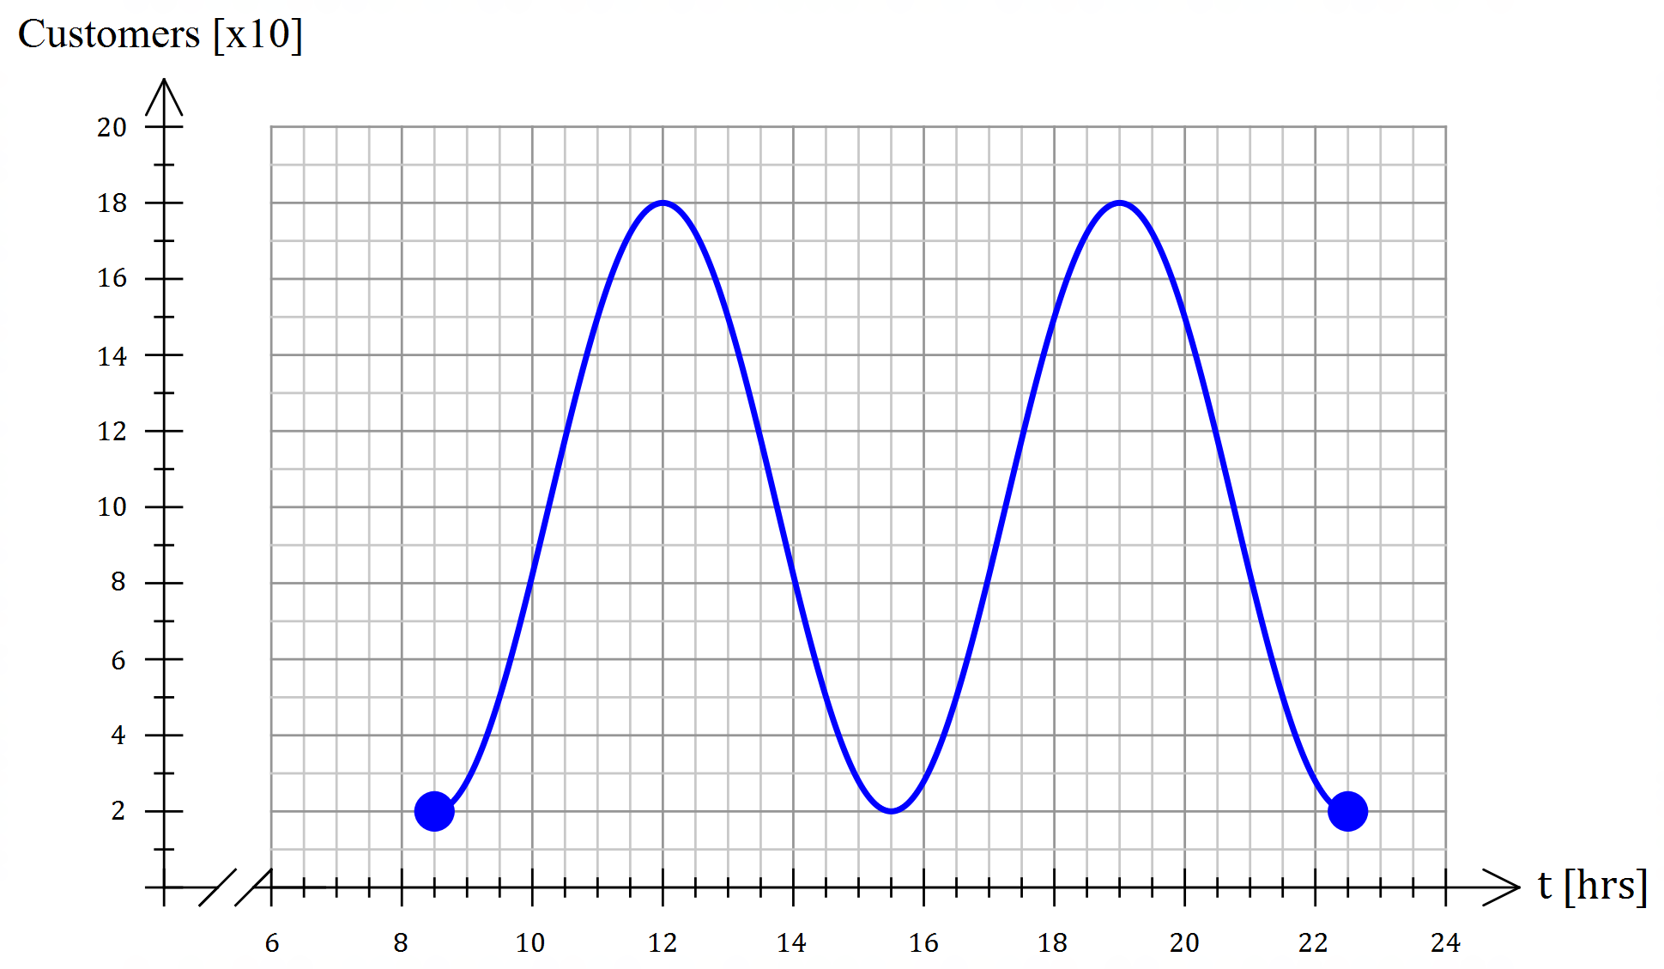16. (a)

✓ Amplitude

✓ Period = 7hrs

✓ two full waves

16. (b)

✓✓✓✓

OR

(c) ✓

CAS: ✓✓

Between 10:50am and 1:11pm ✓

and 5:50pm and 8:11pm ✓ [12]

17. (a) (i) ✓✓

(ii) ✓✓

(iii) ✓✓

(iv) ✓✓

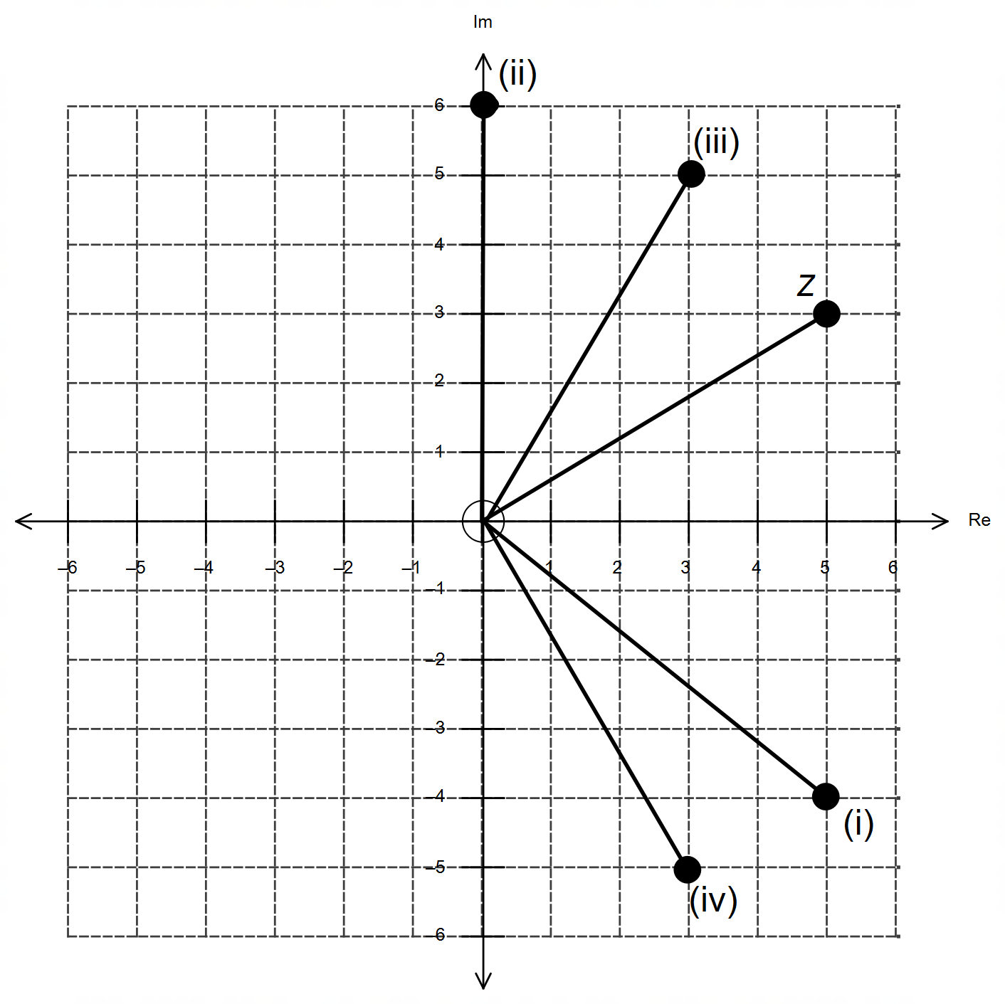

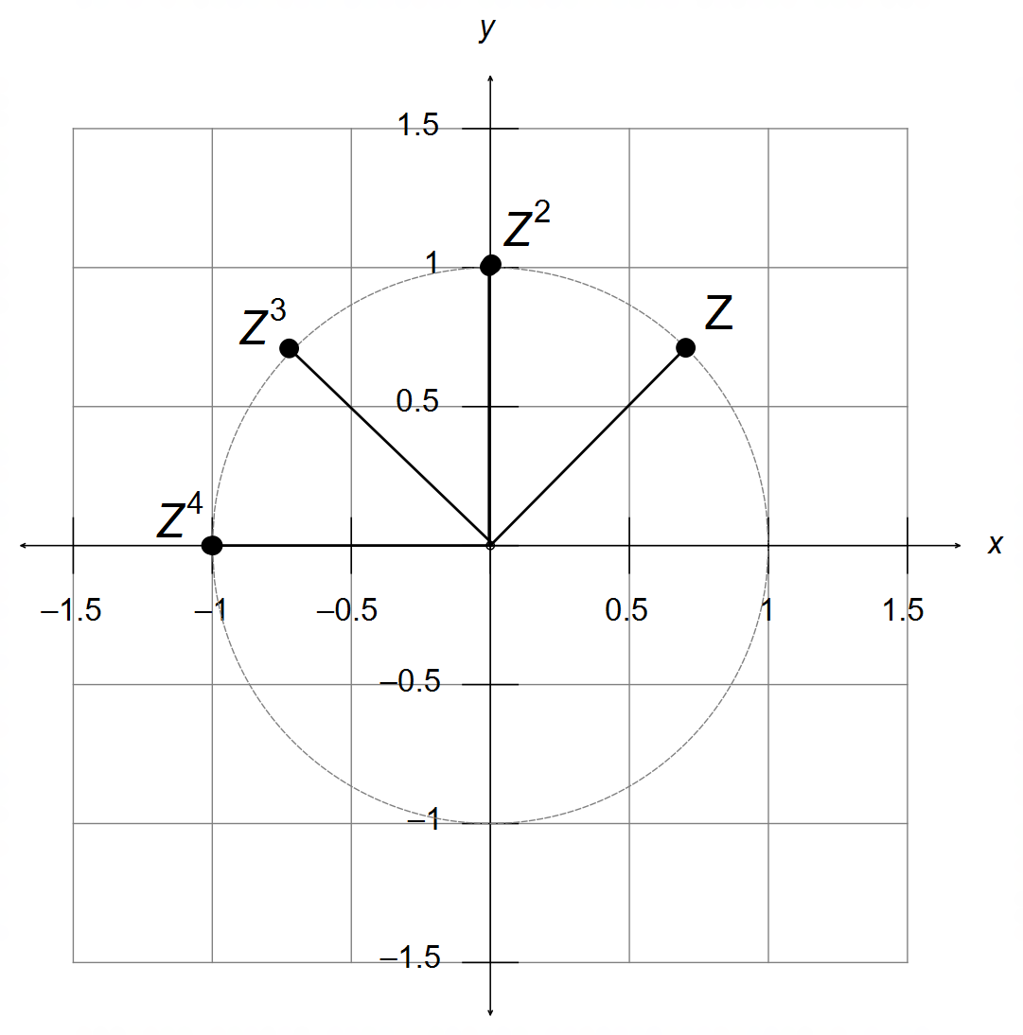17. (b) (i)

✓✓✓

(ii) Rotation ✓ of 45° anticlockwise ✓

(iii) Powers that are multiples of 8 give ✓ [14]

18. (a) ✓

✓

✓

(b) (i)

Rotation of 90° anti-clockwise ✓✓

(ii) $T=\left[\begin{matrix}0 & -1 \\ -1 & 0\end{matrix}\right]$

Reflection over the line ✓✓

(c) i.e.

✓

and ✓✓

OR $\cos{θ}+\cos{ϕ}=0$ and ✓✓ [12]